**STUDENT TRAINEE MANAGEMENT SYSTEM**

Developed For

Air India Ltd.

A Project Report Submitted in Partial fulfillment of the requirement of the award of the degree of

**Bachelor of Computer Science**

**By**

**Permil Garg**

**08429802013**

**July 2015**

**Acknowledgement**

I would like to express my special thanks of Air India Ltd. for provide me the golden opportunity to do this training and gratitude to my project guides as well as our teachers who helped me and provide a strong support which also helped me in doing a lot of Research and i came to know about so many new things I am really thankful to them.

Secondly i would also like to thank my friends who helped me a lot in finalizing this project within the limited time frame.

(Permil Garg)

**Introduction**

The project titled “Student Trainee Management System” is being developed by Permil Garg in the Air India Ltd., New Delhi. Air India enrolls students from various technical colleges for the project work.

Students are selected on their skills and other organizational parameters and as per project requirements. Selected students are work on given project under the provided guide. In this project, I am work on this project because; I see this manual process consumes lot of man power and time. This project includes the making of web based application which can handle all the manual work and make it faster and reliable. It is easily manageable. This web enabled software will help in the enrollment of the new trainee’s and give required information which is useful during the training. This system can generate several types of reports. This system also gets rid of some silly mistakes like spelling mistakes and the heavy registers. This system of provide information to various departments without the loss of time. This system can transform the heavy registers in the electronic data. This system has powerful search system. The records maintainers can get relax and trainee student get their certificate in few clicks.

**Objective**

1. Study of existing system.
2. Enhancement in existing system
3. Design of new system
4. Design and development of database
5. Design and development of web pages
6. Security and authentication
7. Testing and implementation of web based TMS

**Advantages of the project system**

1. Fully web based
2. Easy maintenance of data
3. Trainees can enroll online
4. No delay in long process
5. Easily reports can be generated
6. Less manpower and manual work
7. Save lot of time

**Existing System**

In this system we try to analyze the problems of the existing system, defined the objectives to be attained by solution and evaluate various solution alternatives

**Limitations of existing system**

Existing trainee management system is suffering from the various limitations

1. The existing system is manual.
2. Difficult to maintain.
3. Selection process may take long time.
4. Consumes lot of energy and time.
5. Delay in issuing certificates.
6. Difficult to care heavy registers
7. Heavy registers may be damaged with time.

**Objective of the project**

1. Development of required documents
2. Analysis of the available database
3. Design of web pages
4. Development of code for web pages
5. Implementation of validations
6. Testing of all the components
7. Implementation of the system.

**System Requirement and Specifications**

SRS refers to the process of the specifying the requirements formally in a document and get it approved by the client. SRS documents all the ideas into the formal document that acts as a standard to be referred any time during the software development process. Requirements and specifications are the very important components in the development of any project. Requirements analysis is the first step in the system design process, where a user's requirements should be clarified and documented to generate the corresponding specifications. While it is a common tendency for designers to be anxious about starting the design and implementation, discussing requirements with the customer is vital in the construction of safety-critical systems. For activities in this first stage has significant impact on the downstream results in the system life cycle. For example, errors developed during the requirements and specifications stage may lead to errors in the design stage. This leads not only to more time wasted but also the possibility of other requirements and specifications Therefore, it is necessary that the requirements are specified correctly to generate clear and accurate specifications.

The first step toward developing accurate and complete specifications is to establish correct requirements. In requirements, it is important to specifically establish the functions, attributes, constraints, preferences, and expectations of the product. Usually in the process of gaining information, functions are the first ones to be defined. Functions describe what the product is going to accomplish. It is also important to determine the attributes of a product. Attributes are characteristics desired by the client, and while 2 products can have similar functions, they can have completely different attributes. After all the attributes have been clarified and attached to functions, we must determine the constraints on each of the attributes. Preferences, which is a desirable but optional condition placed on an attribute, can also be defined in addition to its constraints. Finally, we must determine what the client's expectations are. This will largely determine the success of the product.

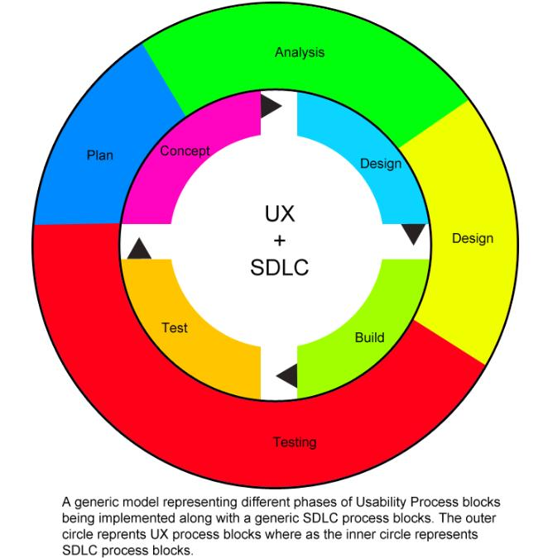

There is waterfall model is used in this student trainee management system.

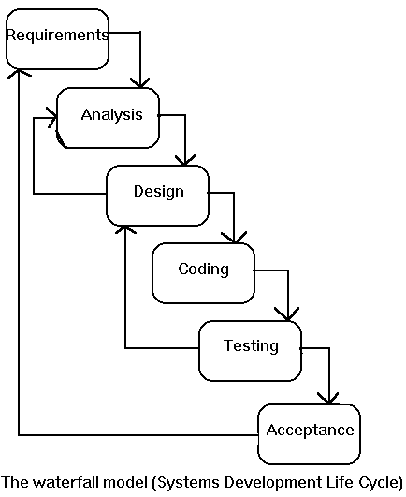

The System Requirement Specification for as system should have the following characteristics :

* SRS should specify all the functions that the software is supposed to do and response to various inputs.
* Requirements stated should not be ambiguous. Formal language specifications should be used.
* Requirements stated should be verifiable & should not conflict with one other.
* SRS should be flexible enough to incorporate any change to it.

**Main components are**

* Functional requirements
* Performance requirements
* Design constraints

**Functional Requirements**

The development of Training management system is required for removing the drawback of the existing system. Air India Ltd. enrolls final year students from various technical educational institutions for undertaking full semester project work. Students are selected on the basis of various organizational parameters and the skills of the student under which the project is to be done & availability of suitable projects in Air India Ltd. Selected Students are normally eligible for training as per requirement of project. Before trainee management system, the information are maintained manually which involves large manpower, and consumes a lot of time and hard to maintain the heavy registers of information. The web-enabled software will help in the answer of certain queries and also generating reports that are to be used by the various other departments time to time. Functional requirement specify all the functions of the system and the outputs to be produced from the given inputs. These requirements explain the input-output relationship between the entities of the system. Mainly the functions are displayed with the help of use case or dataflow diagrams.

So the inputs for the new system are to make the existing system. Fully web based, remotely access, online registration, Easy maintenance of large volume of data, No delay in selection procedure, easily reports will be generated, efficient data storage in database, efficient utilization of resources, Easy manipulation & retrieval of student’s information. So to meet the requirement as given above we have to develop a web application. The new system requires various web forms for performing the online registration, selection task & data retrieval, generating reports. System Requirements are being categorized in following modules:

* Data Entry
* Data Processing
* Reports
* MIS

**Performance Requirements**

These requirements specify the performance characteristics of a system. There are two types of performance requirements:

* Static Requirements
* Dynamic Requirements

Static Requirements also called as capacity requirements, these do not affect the executions of the system. While Dynamic requirements specify constraints related to the time in which the system is able to complete an operation and the number of operations that a system performs in a unit time.

**Design Constraints**

Design constraints cover the various aspects as given :

* Software & hardware limitations
* Security
* Standards

**Technical Architecture**

The requirements for building the trainee management system project, we require the following software’s and compatible hardware support.

* Windows
* Dot Net Framework 4.0
* MS-SQL Server 2008
* Visual Studio 2010

In project a purely web enabled software will be developed using ASP with Dot Net Framework 4.0, MS-SQL Server is used as backend Database. The system will take care of each and every information of the person who are doing or have done there project work at Air India Ltd. Dynamic web pages based on client server model are to be developed, so that the trainees can apply and interact online.

**ASP with Dot Net**

ASP.NET is an open-source server-side Web application framework designed for Web development to produce dynamic Web pages. It was developed by Microsoft to allow programmers to build dynamic web sites, web applications and web services.

It was first released in January 2002 with version 1.0 of the .NET Framework, and is the successor to Microsoft's Active Server Pages (ASP) technology. ASP.NET is built on the Common Language Runtime (CLR), allowing programmers to write ASP.NET code using any supported .NET language. The ASP.NET SOAP extension framework allows ASP.NET components to process SOAP messages.

ASP.NET is in the process of being re-implemented as a modern and modular web framework, together with other frameworks like Entity Framework. The new framework will make use of the new open-source .NET Compiler Platform (code-name "Roslyn") and be cross platform.

**Why Dot Net Used ??**

* Dot Net is platform and hardware independent. In every OS the ASP with Dot Net give the same result very fast.
* When properly applied, the features of ASP Dot Net (eg. Encapsulation, inheritance, etc.) combine to produce a programming environment that supports the development of far more robust and scalable programs.
* A well-designed hierarchy of classes helps programmers in reusing the code.
* Polymorphism (one interface multiple methods) allow a programmer to create clean, sensible, readable and resilient code.
* Asp with dot net is a web development centre. It is specially designed for this.
* Asp with dot net is strictly object oriented language like java.

**MS SQL Server**

The main features of the MS SQL Serves are following

* **High Availability** : Failover clustering and database mirroring technology in SQL Server 2008 will provide high reliability and availability.
* **Management Tools** : SQL Server has an integrated suite of management tools and management application programing interfaces (API) to provide ease of use, management and support.
* **Security Enhancement** : SQL server 2008 has been designed to provide the highest level of security and having default features like encryption, password policy enforcement, permission managements, etc.
* **Scalability** : it provide features like table partitioning, replication enhancement and 64-bit support.

**Visual Studio**

The main features of MS Visual Studio are following

* A powerful code editor with syntax highlighting and auto completion.
* A powerful debugger
* An advance designer which provide a code and design view in split and full mode.
* Properties editor
* Object browser
* Solution explorer
* Data explorer
* Support extension which provides customized features.

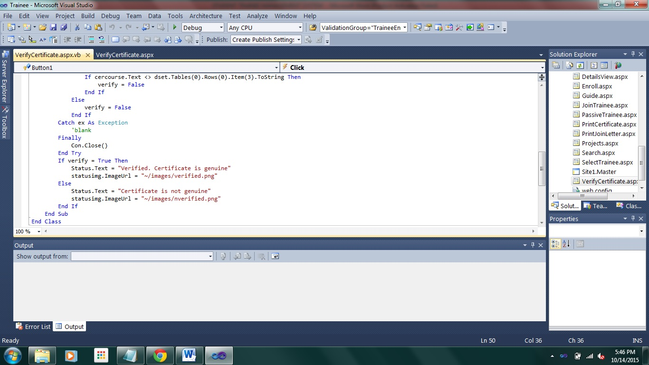

**Hardware and software Requirements**

Servers

* Processor : 1Ghz
* Ram : 4GB
* Hard-disk : 1 TB
* Database : MS SQL Server

Client

* A web-browser (prefer Google Chrome updated)
  + Supported all web-browser
* A stable internet connection

**Data-Flow diagrams**

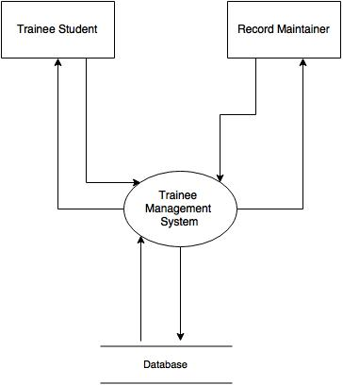

**Leve1 0 DFD/Context Diagram of TMS**

**ER diagrams**

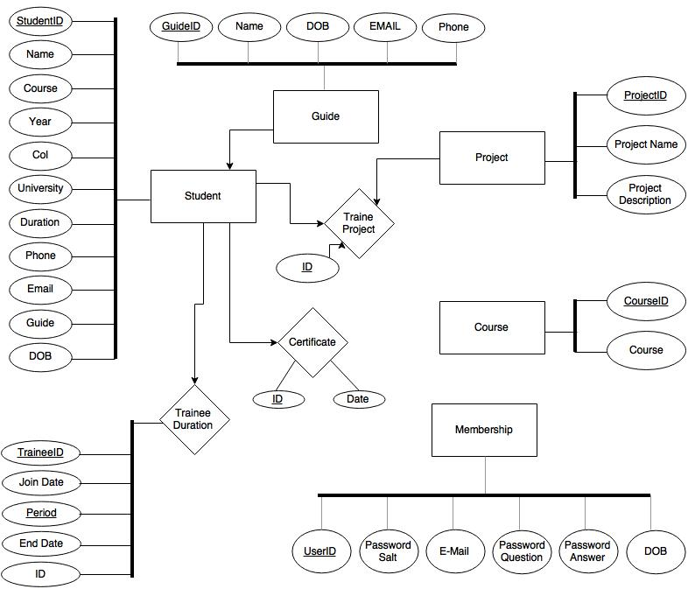

An Entity Relationship diagram of the project Trainee Management System

**Use case diagrams**

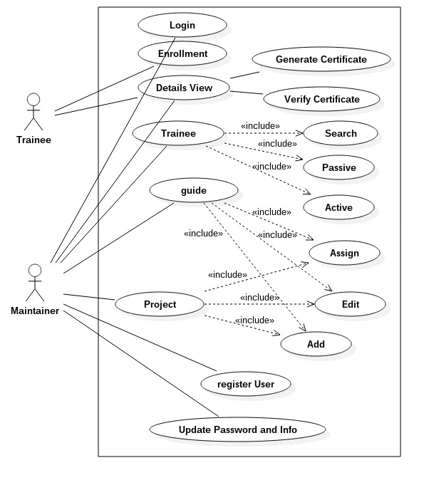

**Screenshots**

There are several screenshots which show the features and look of the project TMS

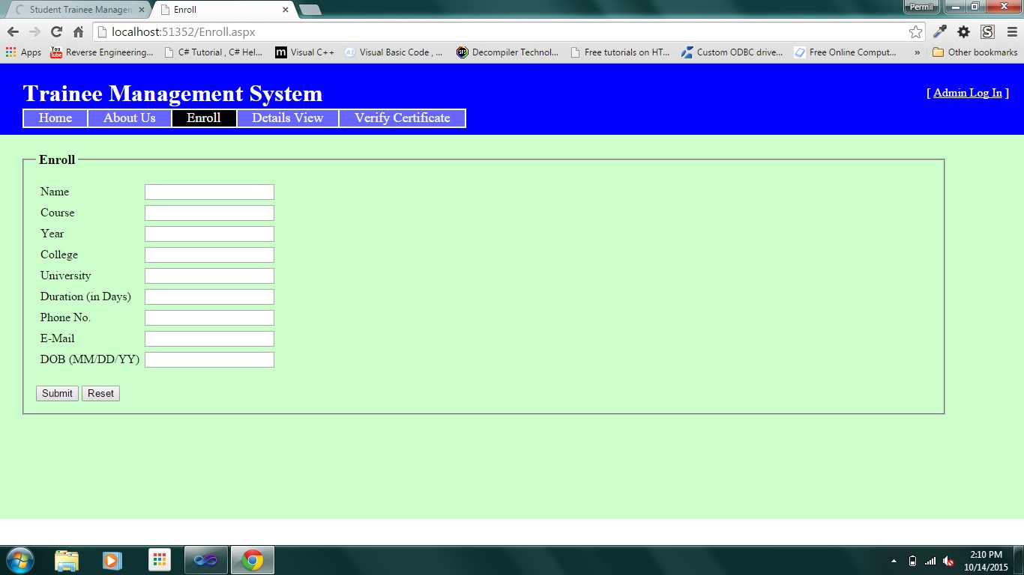An Enroll Form of Trainee student

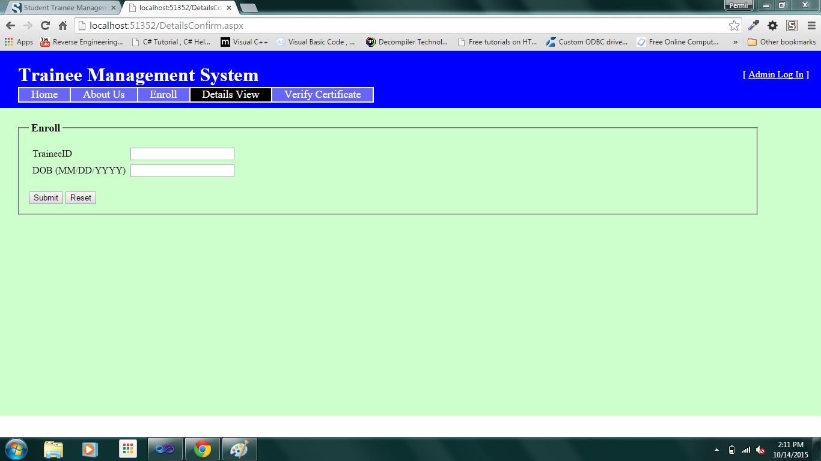

A detail view authentication page

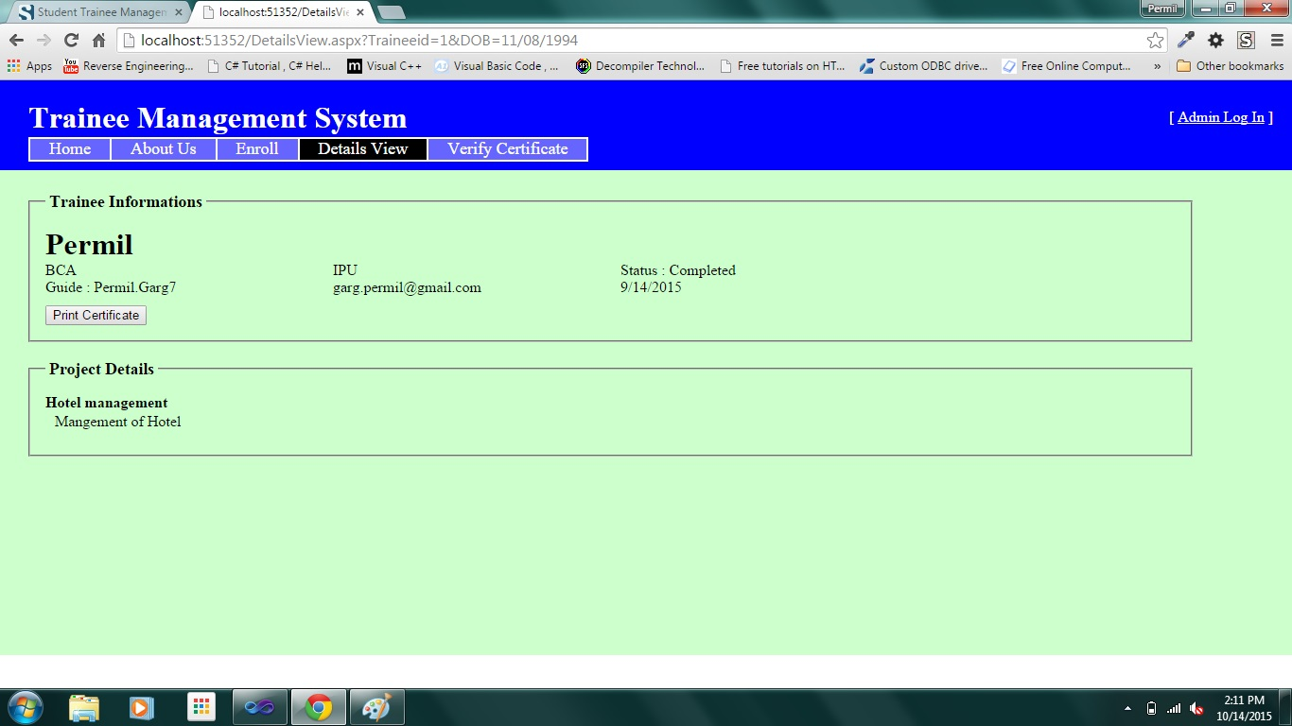

A detail view page

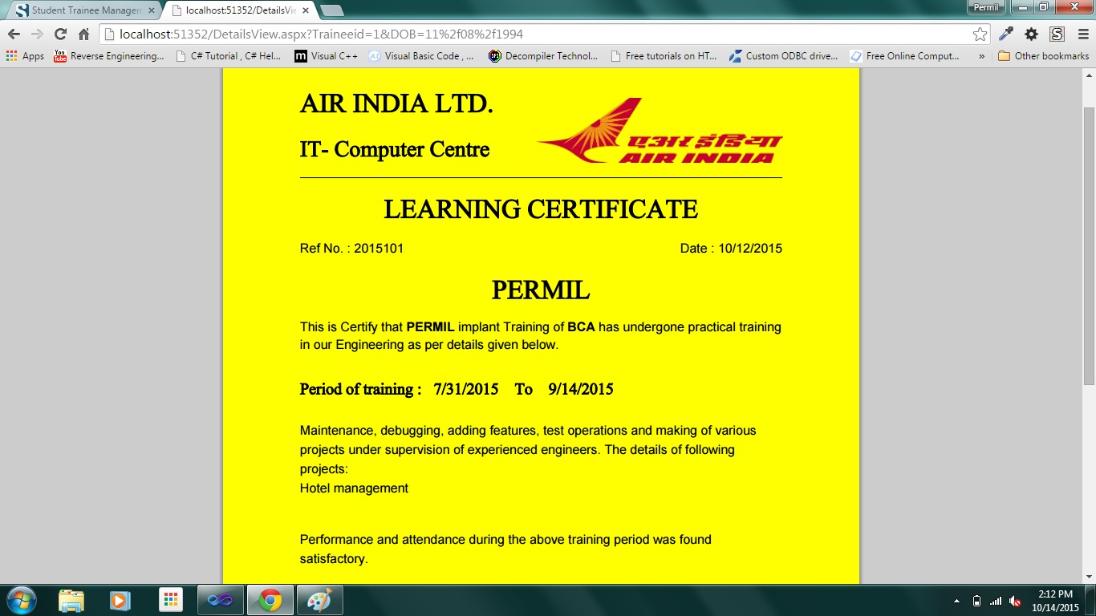

A certificate

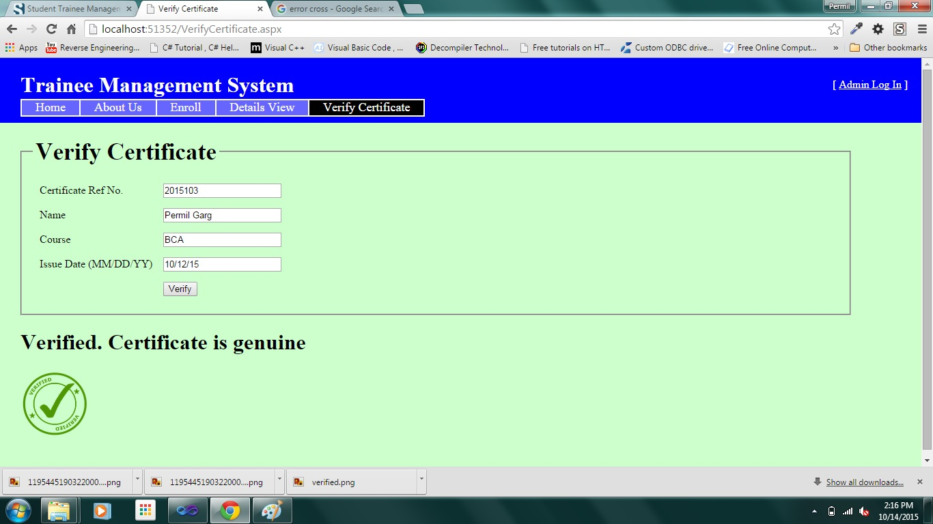

A page showing of verified certificate

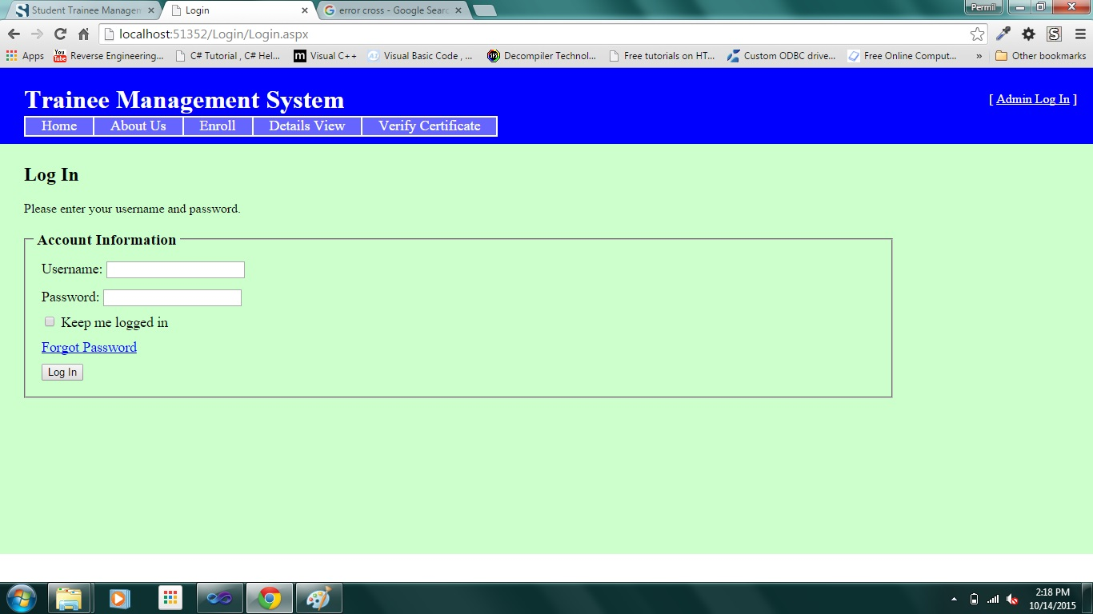

A record maintainer login page

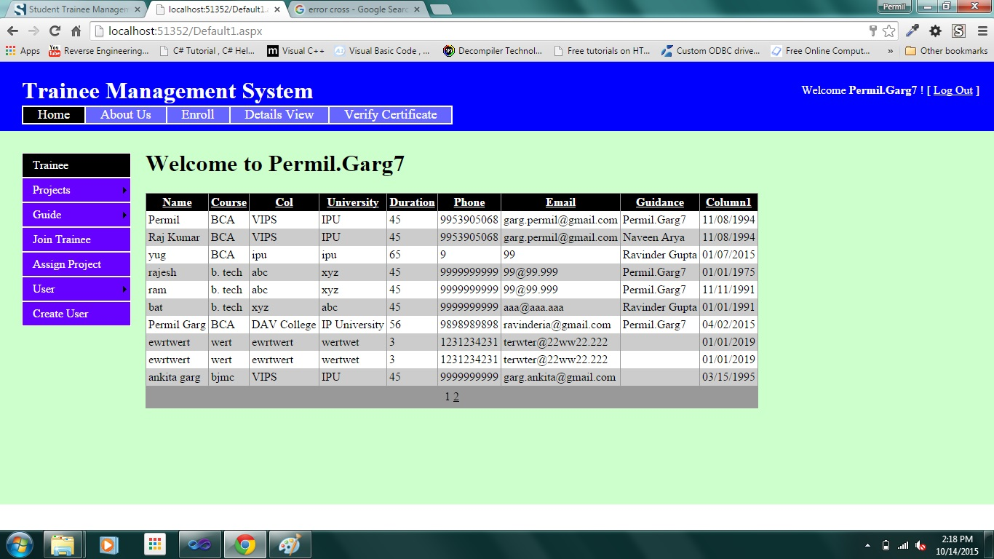

A home page of login

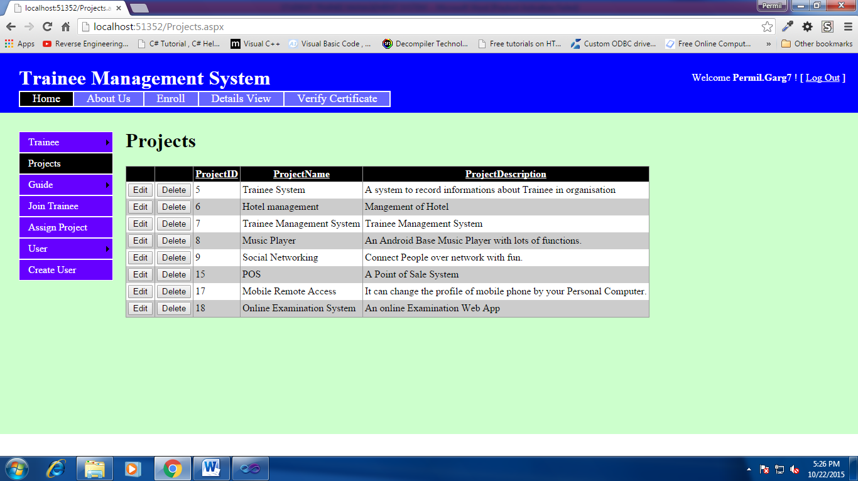

A page showing details of projects

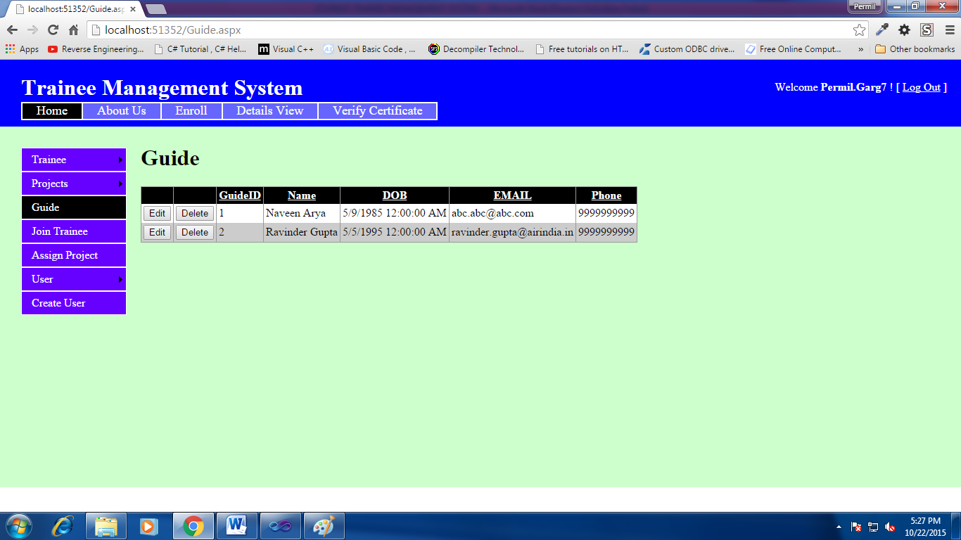

Showing the list of guides

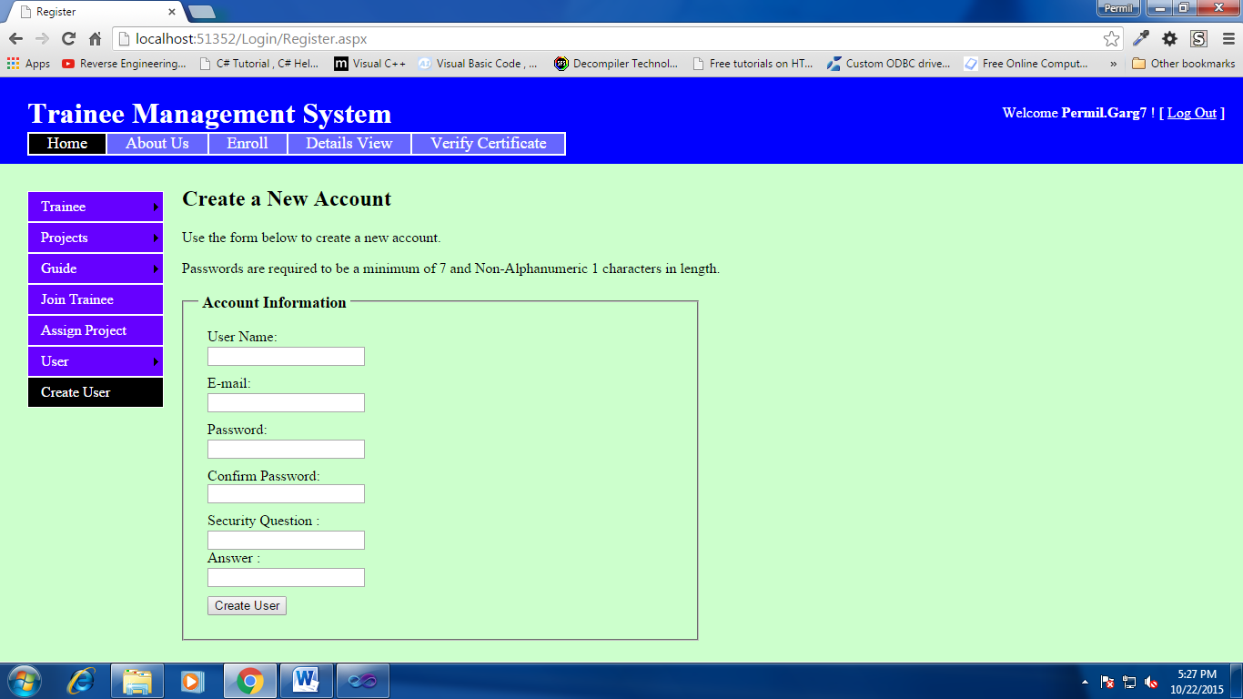

A maintainer user create form

**Bibliography**

We want to special thanks for helping in this project to complete.

1. Air India Ltd.
2. Google
3. Microsoft
4. Stackoverflow.com
5. Wikipedia.com
6. Codeproject.com
7. Scribd.com
8. Aspdotnet.com
9. Asp.net
10. aspsnippets.com